A little defender
Table of Contents
Записки дма 3
Глава 1: The beginning of all 4

Записки дма
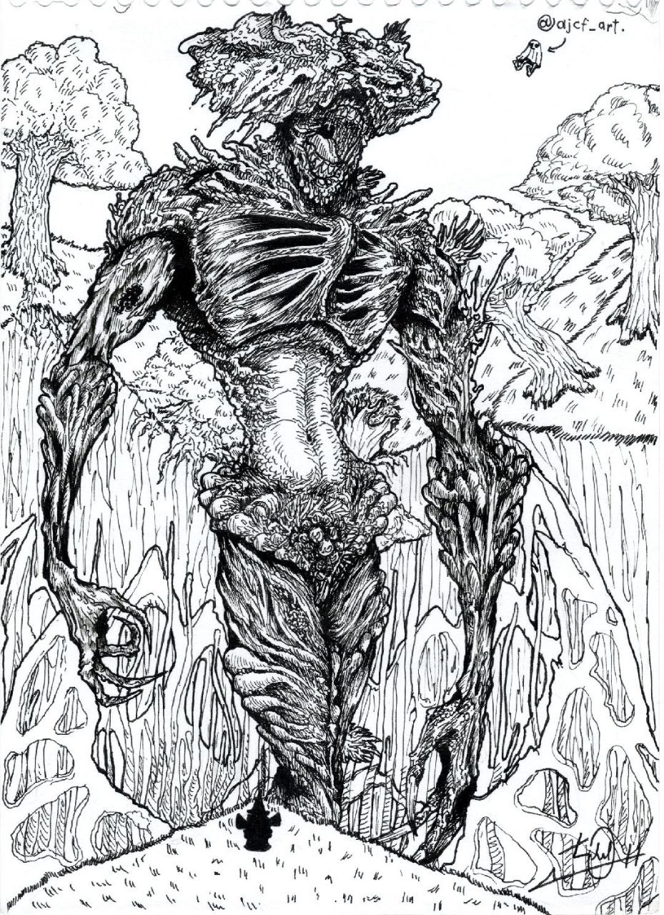
This novel I highly expired by creation of AJCF

Chapter 1: The joy of new sons
- Rise my dearest child
And a plant started to grow. Its roots destroyed ground and flew high in the air. Plant started to form humanoid form and stand on its legs. Monstrous creature stood tens of meters high and shout its roar. Ground

